SUPPLEMENTARY MATERIAL

A novel robotic reaching task to advance the assessment of approach-avoidance tendencies through kinematic analysis

Kayne Park, Matthieu P. Boisgontier

Supplementary Material 1. Screenshot of the General tab in the sandwichOrder.dtp file
Supplementary Material 2. Screenshot of the Target Table tab displaying columns used to set target properties.
Supplementary Material 3. Screenshot of the Trial Protocol (TP) Table identifying the targets to use for specific columns.
Supplementary Material 4. Screenshot of the Task Wide Params tab.
Supplementary Material 5. Screenshot of the Block Table highlighting the TP List, List Reps, Randomized, and Block Reps.

Supplementary Material 1. Screenshot of the General tab in the sandwichOrder.dtp file
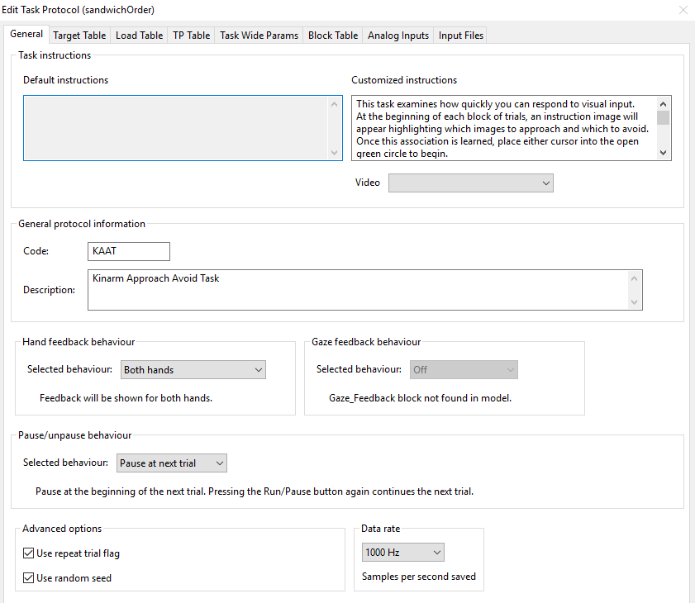

Supplementary Material 2. Screenshot of the Target Table tab displaying columns used to set target properties.
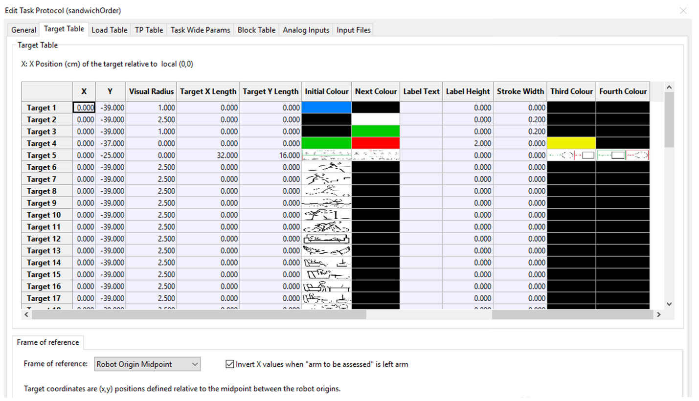

Supplementary Material 3. Screenshot of the Trial Protocol (TP) Table identifying the targets to use for specific columns.
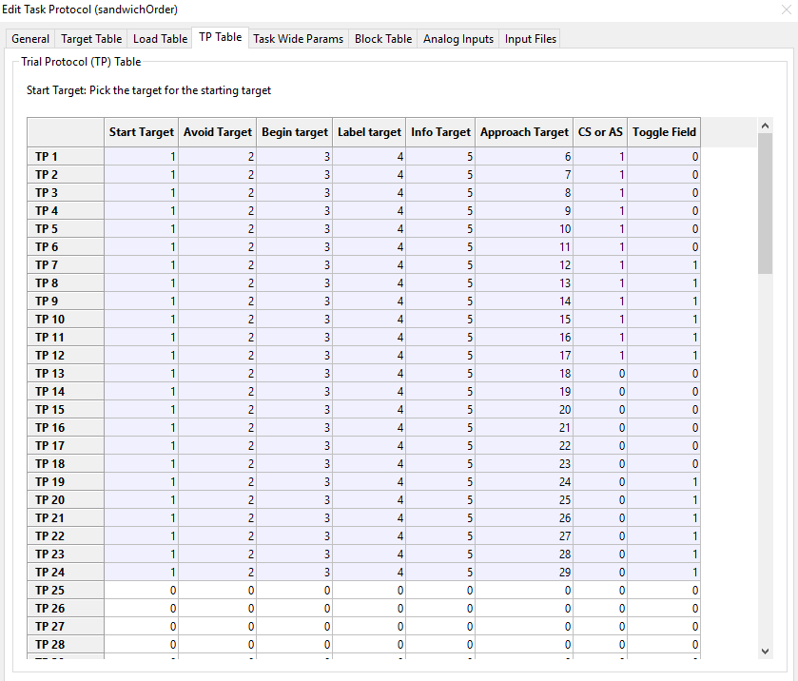

Supplementary Material 4. Screenshot of the Task Wide Params tab.
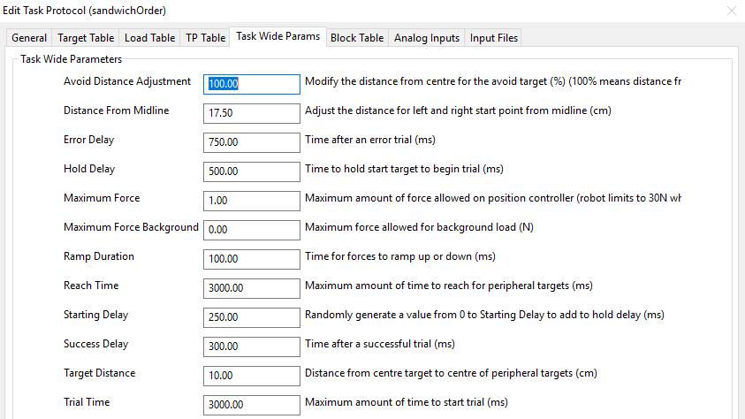

Supplementary Material 5. Screenshot of the Block Table highlighting the TP List, List Reps, Randomized, and Block Reps.
